**PREREQUISITES**

1) Installed NodeJS

2) IDE for NodeJS (ex: [visual studio code](https://code.visualstudio.com/))

**INSTALL NODE JS**

Download Node JS <https://nodejs.org/en/>

(Node Version 8.11 or higher)

**SETTING UP THE CODE**

1. Extract the node-js-cook.zip to whichever directory you want
2. Using the command prompt/powershell or git bash go to node-js-cook folder
3. Type npm install to install all dependencies

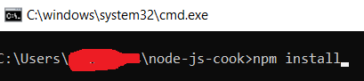

1. add the following in your environment variables

* LMS_WS_PASSWORD=" m4)K@^Psle@i "
* LMS_WS_USERNAME="COOKCH_PRD_wsvc"
* SOAP_ACTION="<http://vuepoint.com/UpdateUserTranscript>"
* LMS_WEBSERVICE_ENDPOINT="<https://cookchildrens.certpointsystems.com/wa/ws/ver5/vlsadmin.asmx>"
* PORT = 8080 or whichever port you want

1. restart command prompt/powershell or git bash

**RUNNING THE CODE**

1. type npm start

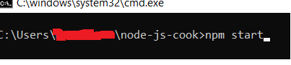

1. verify in browser run [http://localhost:<PORT>/start](http://localhost:%3cPORT%3e/start)

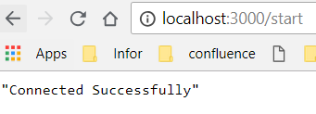

**DEPLOYING IN IIS**

1. Refer to this link <http://www.goktay.net/using-node-js-with-iis>

**SETTING UP PROCESS MANAGER RUNTIME**

1. Using the command prompt/powershell or git bash ­type “npm install pm2@latest -g ”.



1. Go to the application folder and type “pm2 start app.js”



For more reference refer to <https://pm2.io/doc/en/runtime/overview/>/